



Fresno Center for Nonviolence

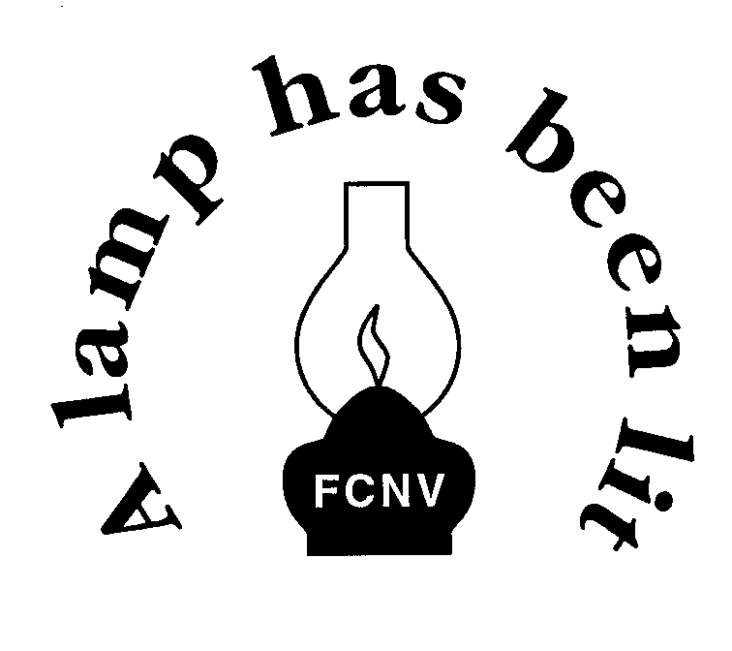

1584 N. Van Ness Ave., 93728 - www.centerfornonviolence.org - email: info@centerfornonviolence.org
Across from Fresno City College * SE Corner Van Ness & McKinley Ave. * Entrance on Van Ness Ave. *
Our Staffed Open Hours are: Mon thru Fri, 11 AM - 3 PM. (559) 23PEACE, (559) 237-3223
dedicated to PEACE and SOCIAL JUSTICE through
SIMPLICITY ~ JUSTICE ~ INCLUSIVENESS ~ NON-INJURY
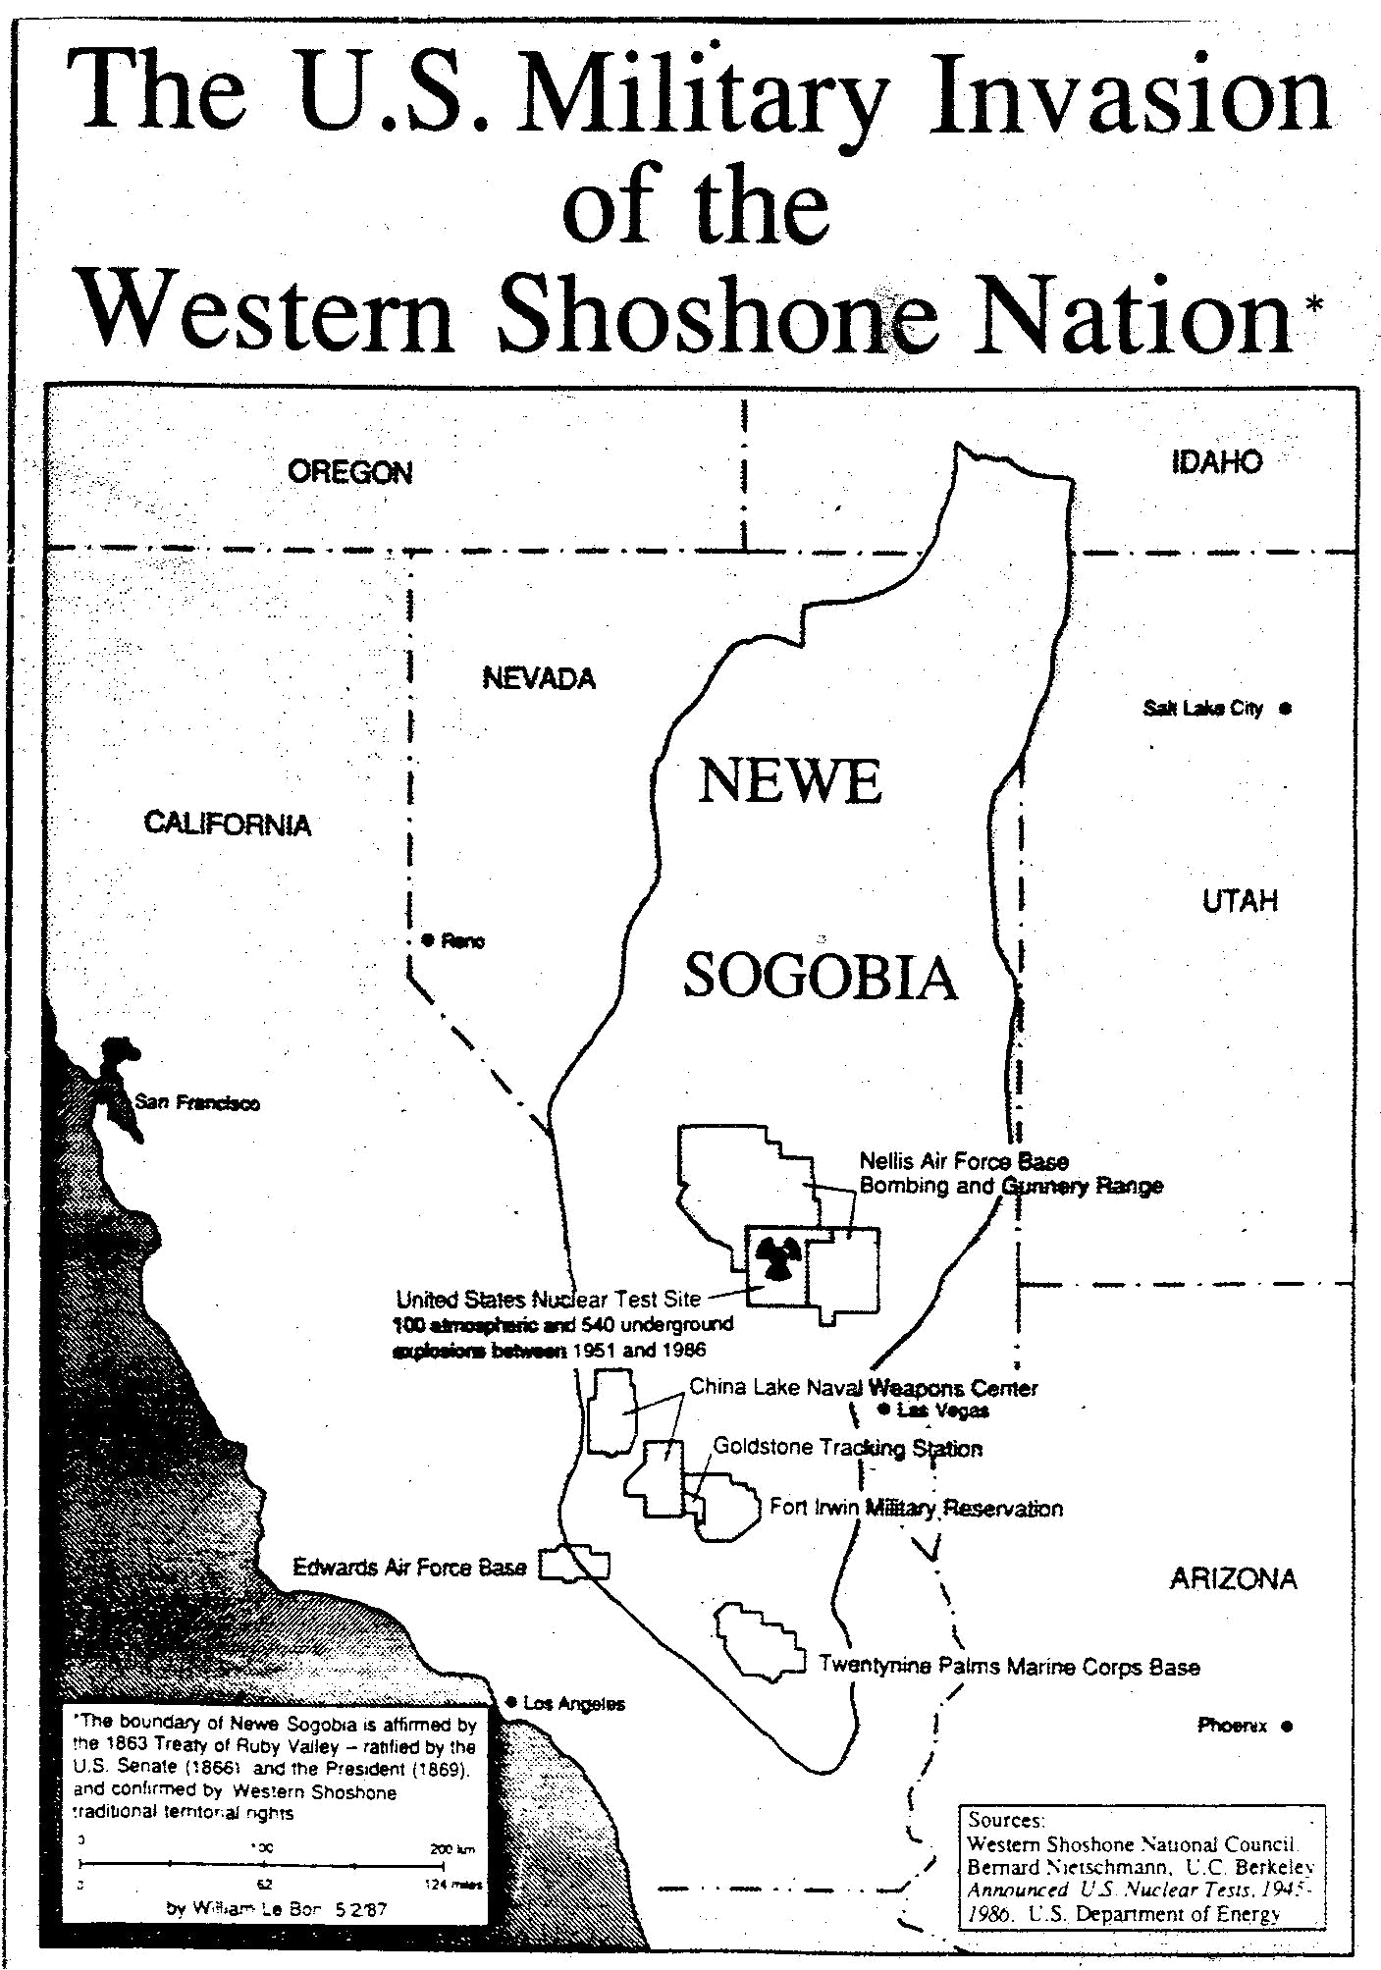
♫ “…99 nuclear bombs on the wall, 99 nuclear bombs on the wall, if one of them falls, 98 nuclear bombs on the wall ♫…” to the tune of “99 bottles of beer”, was ringing in my ears as the busses that were taking me and about 100 men and women, all handcuffed, to Tonopah, NV to be processed for trespassing into the Nuclear Test site where thousands of nuclear weapons had been demonstrated to show how destructive the human race can get. Strangely enough, the hundreds of us had actual documented proof to be there given to us by the Western Shoshone whose ancestors have lived there since the beginning of time while not one member of the Wackenhut security or government officials had any. It seems that the state and Federal agencies were also worried we were collecting ammunitions to attack the Nuclear Test site so commenced to removing every rock, stones and pebble that they thought could be dangerous but in truth our support groups of people had assembled those rocks and stones into mini-peace symbols and monuments that were quickly taken away by the state of Nevada waste disposal system. Ah yes, the good old days when most people who were aware expected the human race to go out with a bang or a whimper. Unfortunately our nuclear past, like our nuclear present has been swept under the carpet or tossed out to sea like a note in a bottle. This problem has and should continue to haunt us and future generations despite our government’s lies.
Although the U.S. is obligated to disarm under the Non-Proliferation Treaty, the U.S. is devising new nuclear weapons for a trillion dollars while the Pentagon plans ways to use them.

Over 30 years and our government still are frightened of us. Hide behind laws and the police, they lie to us while they smile and try to gives us our daily emotional bread of fear to manipulate us into inaction or actions. If I sound a bit upset well because it’s true. Since then I have lost some friends to an assortment of ailments caused by the nuclear radiation from our government testing. Unfortunately this ailment has been going around the world since 1945. It’s been said that the truth may hurt but the lies kill, doesn’t it? So what do we do? Maybe I should reach into and grab your soul, pull it out and tear it open like a walnut while a horrible hideous scream stream out of you revealing the only thing left that we all have; ourselves in a singular sense with nothing to hide and nothing to loseor win but then that is everyones own individual lives chore.
On Tuesday, August 9th, Nagasaki Day 2016, many will once again gather to remember the 71st anniversary of the U.S. atomic bombings of Hiroshima and Nagasaki at Livermore Lab where the latest budget request shows the 86% of its funding is for nuclear weapons. Scientists are developing the new modern bombs. As per his pledge to reduce the nuclear stockpile of older weapons, President Obama wants to get rid of old bombs for more efficient nukes that are smaller and able to rain unimaginable devastation anywhere on Earth. Those gathering will also include Japanese Hibakusha (A-bomb survivors), Pacific islanders and other’s impacted by deadly nuclear technology to proclaim, “Never Again!” To join them call, Tri-Valley CAREs at (925) 443-7148 or www.trivalleycares.org

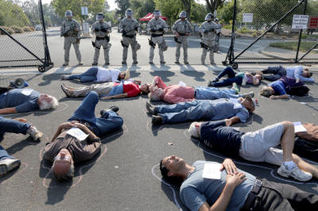
It is times like these I can understand why people would look up and cry out to the sky for sanity. There doesn’t
seem to be any down here. But weather it was set up by some mysterious entity that left us this world to figure out
how to play nice with each other or total random luck(?).
I remember a very wise spiritual teacher, at least until the IRS took him away for tax evasion, telling me and others
that everything around us is merely a reflect ion of our own selves. So when we see arguments, fighting,
killings and all such other forms of human abuses; we actually see what is going on inside of us. Resolve the issue
in ourselves and the world would replace the abuse with peace or at least chocolate. Otherwise life might as the
song did, “…♫If one nuclear bomb should happen to fall, ♫“follow by noises of yelps, screams, howls from their
inner souls to signify destruction of our lives & world. Acknowledge the fear inside then we can deal with the fears
on the outside. Nonviolently yours, Richard Gomez

August: “Countdown to Zero.” Countdown to Zero traces the history of the
atomic bomb from its origins to the present state of affairs: with the world
held in a delicate balance that could be shattered by an act of terrorism,
failed diplomacy, or a simple accident. This video is 91 minutes long.
A review in Daily Variety called the film "highly creative documentary-making" and concluded
that the film makes "a convincing argument that the human race is on borrowed time: Given
the number of nuclear weapons in existence, the ease with which they can be made, the eagerness of terrorists to possess them and a worldwide cluelessness about nuclear security, it's only a matter of time before something terribly ugly happens. A politically urgent picture, it will also literally scare the breath out of what will certainly be a worldwide audience." The trade journal also highly praised the special effects and cinematography for creating "immaculate images". A review for Reuters said the film was "convincingly argued and extremely polished" and described portions as "absolutely chilling."
The Wall Street Journal called the film "hair-raising" and noted that it was one of the rare documentaries to screen at Cannes. Jason Solomon’s, writing for The Observer, said the film was one of "five films to watch" at Cannes. The Guardian described the documentary as "unmissable" and "the best horror film of all time". The Washington Times was highly critical of the film. Its reviewer said the documentary appeared to be produced by "the peacenik movement" and concluded, "The pacifist message of the former is loud and clear: 'Our only option is to eradicate every last nuclear missile'...” -From Wikipedia, the free encyclopedia.
September: “Son of Navajo Boy.” Internationally acclaimed documentary that reunited a Navajo family in Monument Valley and triggered a federal investigation into uranium contamination. It tells the story of Elsie Mae Begay, whose history in pictures reveals an incredible and ongoing struggle for environmental justice.
Fresno Center for Nonviolence begets a trio of good summer videos.

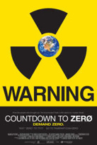





The FCNV is a

for the many non-profit groups in the Fresno community. We provide a safe meeting place and media resources to the groups using our facility, including:
Community Alliance - the 1st Sunday at 1pm,
CVPPAC –the 2nd Saturday at 3:30pm,
Peace Fresno - the 2nd Tuesday at 6:30pm,
FFCF –the 3rd Tuesday at 7pm,
WILPF –the 2nd Thursday at 7pm.
These organizations meet at diverse time, and day. Please check their websites or FB.
CCCJC- www.cccjc.org,
FIYA – Fresno Immigration Youth Action
PMP- Prison Moratorium Project
Earth Day Fresno
Pachamama Fresno Community
and the Raging Grannies – go to WILPF page.



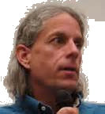

Tune into the Fresno Center for Nonviolence’s monthly “Stir It Up” radio show hosted by Angela Price whose guest will be John LeForge co-director of Nukewatch, a nuclear watchdog group in Wisconsin.
There will be call-ins at (559)266-8888. For info call (559)-237-3223 Mon-thru Fri 11-3pm. So stay tuned...
Our July’s, Stir it Up radio show hosted by Gerry Bill speaking with his guests Ms. Gail Walker, the Executive Director of IFCO/Pastors for Peace and Ms. Isel Calzadilla, an outspoken LGBTH activist in Cuba who was travelling to Cuba with the Caravan. You may listen to it again by clicking on the link below:
https://www.adrive.com/public/mmgrnd/Stir%20it%20Up%20with%20Cuba%20Caravanistas

